**LAB 1: Recovery image**

**Course Name**: FRS301-Digital Forensics

**Student Name**: Nguyễn Trần Vinh – SE160258

**Instructor Name**: Lê Tiến Dũng

**Lab Due Date**: 10/1/2023

**Carve2.bin**

* Using bless to check file Carve2.bin
* Find the header of image: FF D8 FF E0
* Find the end of image: FF D9

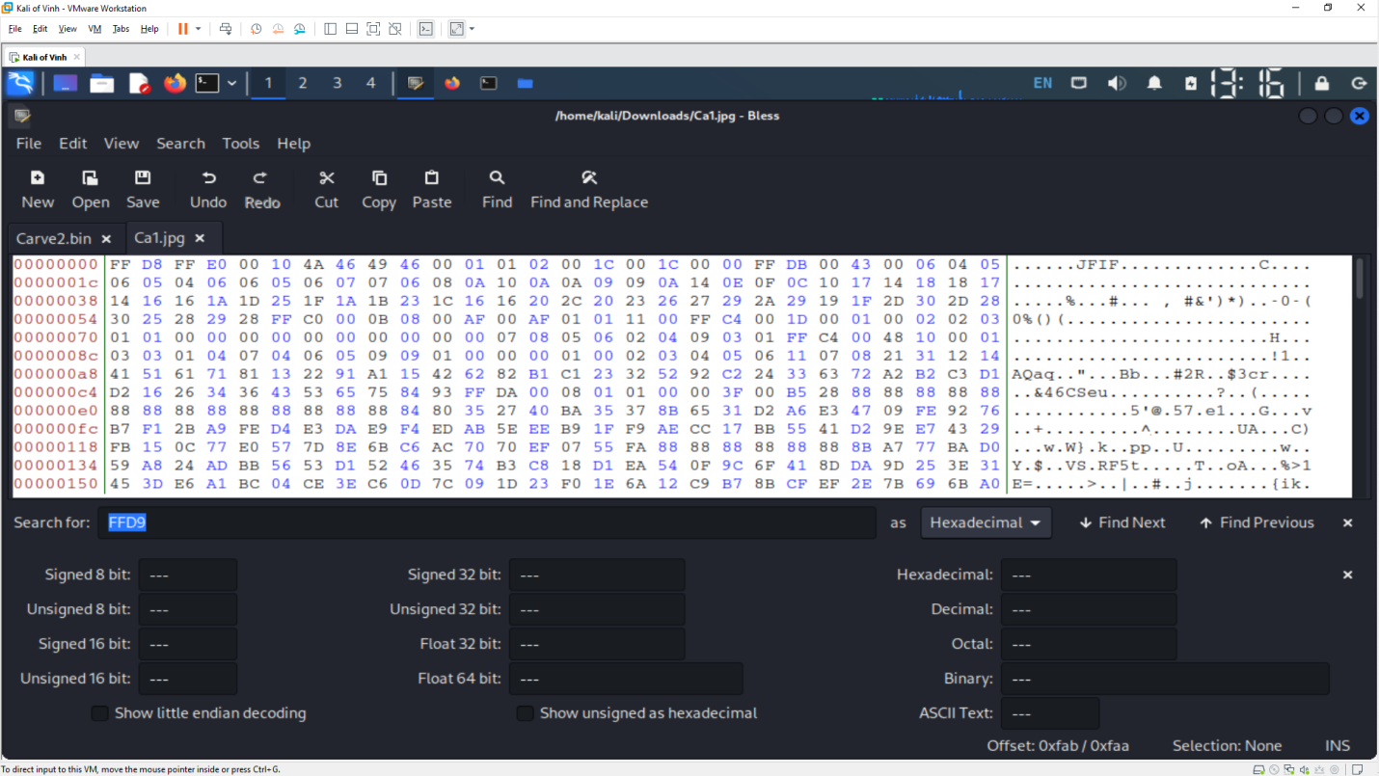 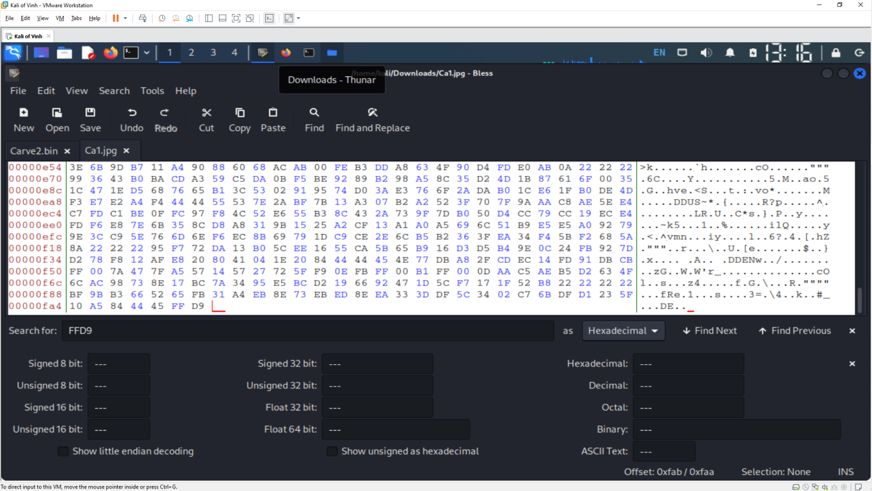 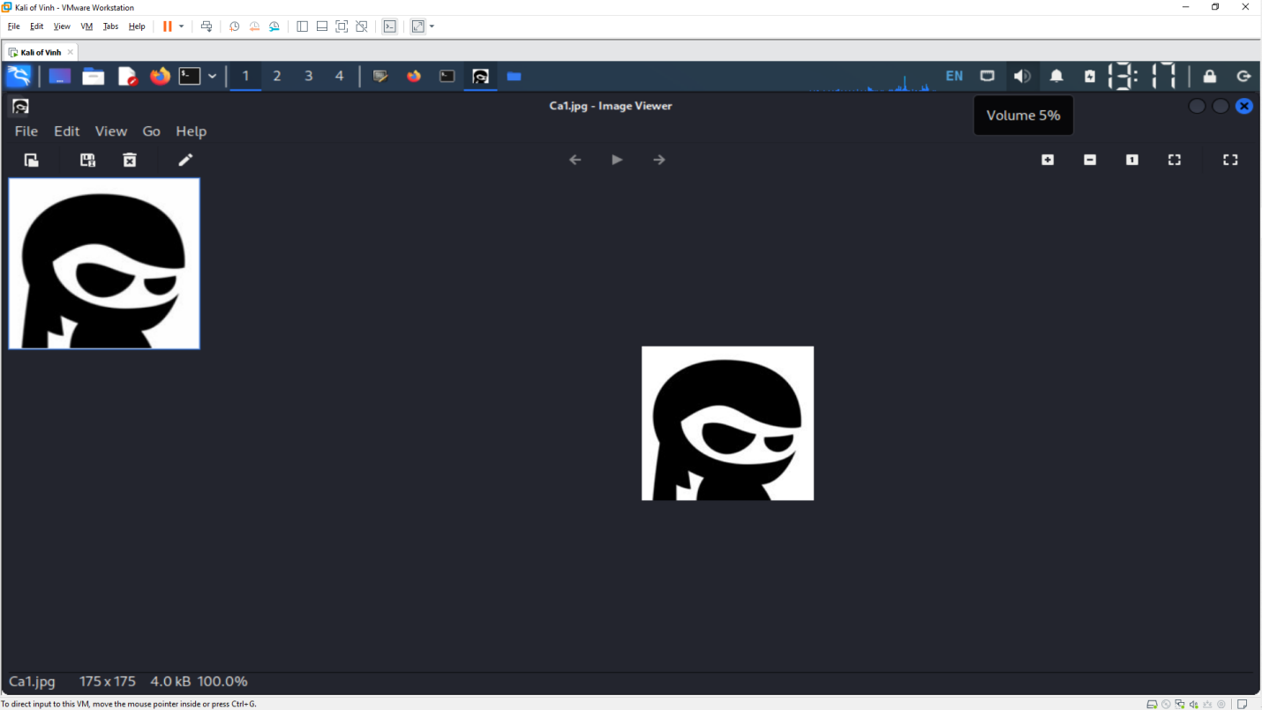

**Carve1.bin**

* Using bless to check file Carve1.bin
* Find the header of image: FF D8 FF E0
* Find the end of image: FF D9

